***Cotton elephant***

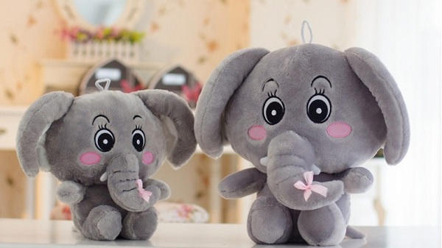

*Cotton elephants are made from high quality cotton.  
There are many colors to choose from.  
Size 40 x 50 cm.  
Perfect as a gift for your girlfriend or children.*